PDC Lab 9 L13+L14
Advait Deochakke
20BCE1143

Q1) Circuit Satisfiability

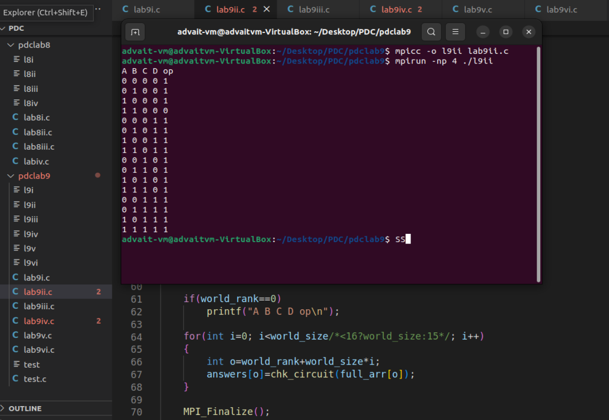
Code ->
#include<mpi.h>
#include<omp.h>
#include<stdio.h>
#include<math.h>
#include<stdbool.h>
//#include<iostream>

//using namespace std;

struct myb{
bool i;
bool j;
bool k;
bool l;
};

#define btoa(x) ((x)?"1":"0")

bool chk_circuit(struct myb boo)
{
// let circuit be ab(and) + cd(or) -> (not)ab(or)cd
bool ans = !(boo.i&&boo.j)||(boo.k||boo.l);
printf("%s %s %s %s %s\n", btoa(boo.i), btoa(boo.j), btoa(boo.k), btoa(boo.l), btoa(ans));
return ans;
}

int main()
{
//MPI circuit satisfiability

struct myb full_arr[16];
for(int i=0; i<2; i++)
{
for(int j=0; j<2; j++)
{
for(int k=0; k<2; k++)
{
for(int l=0; l<2; l++)
{
struct myb bol;
bol.i=(bool)i;
bol.j=(bool)j;
bol.k=(bool)k;
bol.l=(bool)l;
int val=i*8+j*4+k*2+l*1;
full_arr[val]=bol;
}
}
}
}

bool answers[16];

MPI_Init(NULL, NULL);
int world_size;
MPI_Comm_size(MPI_COMM_WORLD, &world_size);

int world_rank;
MPI_Comm_rank(MPI_COMM_WORLD, &world_rank);

if(world_rank==0)
printf("A B C D op\n");

for(int i=0; i<world_size/*<16?world_size:15*/; i++)
{
int o=world_rank+world_size*i;
answers[o]=chk_circuit(full_arr[o]);
}

MPI_Finalize();
return 0;
}

Q2) Number of solutions in circuit satisfiability

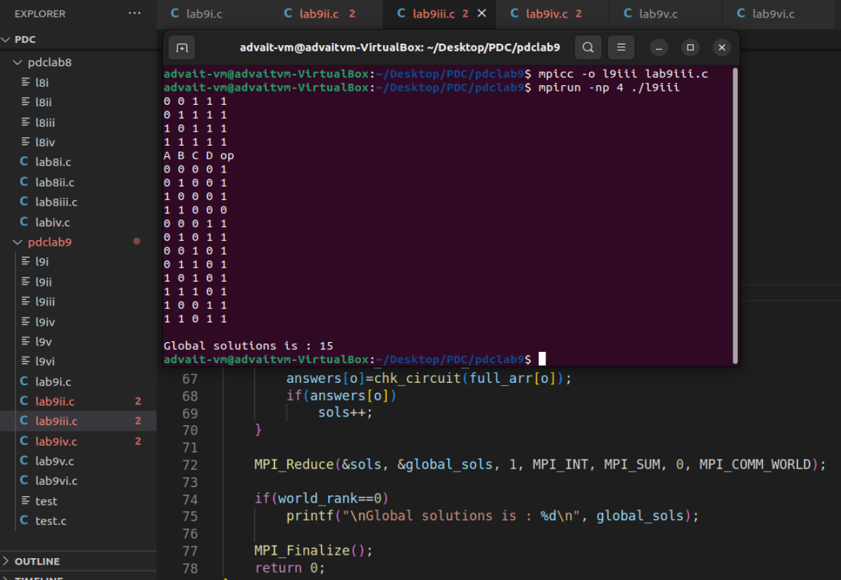
Code->

#include<mpi.h>
#include<omp.h>
#include<stdio.h>
#include<math.h>
#include<stdbool.h>
//#include<iostream>

//using namespace std;

struct myb{
bool i;
bool j;
bool k;
bool l;
};

#define btoa(x) ((x)?"1":"0")

bool chk_circuit(struct myb boo)
{
// let circuit be ab(and) + cd(or) -> (not)ab(or)cd
bool ans = !(boo.i&&boo.j)||(boo.k||boo.l);
printf("%s %s %s %s %s\n", btoa(boo.i), btoa(boo.j), btoa(boo.k), btoa(boo.l), btoa(ans));
return ans;
}

int main()
{
//MPI circuit satisfiability

struct myb full_arr[16];
for(int i=0; i<2; i++)
{
for(int j=0; j<2; j++)
{
for(int k=0; k<2; k++)
{
for(int l=0; l<2; l++)
{
struct myb bol;
bol.i=(bool)i;
bol.j=(bool)j;
bol.k=(bool)k;
bol.l=(bool)l;
int val=i*8+j*4+k*2+l*1;
full_arr[val]=bol;
}
}
}
}

bool answers[16];
int global_sols;
MPI_Init(NULL, NULL);
int world_size;
MPI_Comm_size(MPI_COMM_WORLD, &world_size);

int world_rank;
MPI_Comm_rank(MPI_COMM_WORLD, &world_rank);

if(world_rank==0)
printf("A B C D op\n");
int sols=0;
for(int i=0; i<world_size/*<16?world_size:15*/; i++)
{
int o=world_rank+world_size*i;
answers[o]=chk_circuit(full_arr[o]);
if(answers[o])
sols++;
}

MPI_Reduce(&sols, &global_sols, 1, MPI_INT, MPI_SUM, 0, MPI_COMM_WORLD);

if(world_rank==0)
printf("\nGlobal solutions is : %d\n", global_sols);

MPI_Finalize();
return 0;
}

Q3) Adding a count to all values of a matrix with size n*n
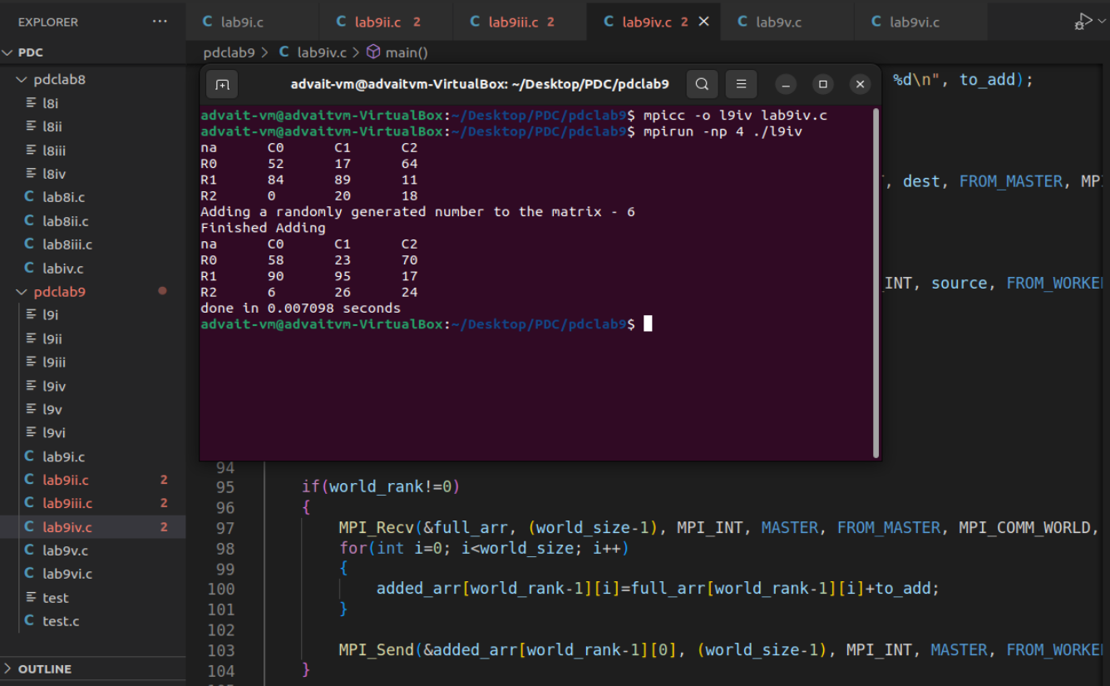

Code ->
#include<mpi.h>
#include<omp.h>
#include<stdio.h>
#include<stdlib.h>
#include<time.h>
#include<math.h>
#include<stdbool.h>
//#include<iostream>

//using namespace std;

#define MASTER 0
#define FROM_MASTER 1
#define FROM_WORKER 2

void printmat(int arr[100][100], int world_size)
{
printf("na");
for(int i=0; i<world_size; i++)
printf("\tC%d", i);
printf("\n");
for(int i=0; i<world_size; i++)
{
printf("R%d", i);
for(int j=0; j<world_size; j++)
{
printf("\t%d", arr[i][j]);
}
printf("\n");
}
}

void addtomat(int arr[100][100], int world_size, int world_rank, int to_add)
{
printf("executing from inside world - %d\n", world_rank);
for(int j=0; j<world_size; j++)
{
arr[world_rank][j]+=to_add;
}
}

int main()
{
//MPI add number to matrix

MPI_Status status;

MPI_Init(NULL, NULL);

int world_size;
MPI_Comm_size(MPI_COMM_WORLD, &world_size);

int world_rank;
MPI_Comm_rank(MPI_COMM_WORLD, &world_rank);

int full_arr[100][100];
int added_arr[100][100];
int to_add;

srand(time(NULL));
for(int i=0; i<world_size-1; i++)
{
for(int j=0; j<world_size-1; j++)
{
int x=rand()%100;
full_arr[i][j]=x;
added_arr[i][j]=0;
}
}

to_add=rand()%10+1;
if(world_rank==0)
{
printmat(full_arr, world_size-1);
printf("Adding a randomly generated number to the matrix - %d\n", to_add);
double start = MPI_Wtime();

for(int dest=1; dest<=world_size-1; dest++)
{
MPI_Send(&full_arr[dest-1][0], (world_size-1), MPI_INT, dest, FROM_MASTER, MPI_COMM_WORLD);
}

for(int source=1; source<=world_size-1; source++)
{
MPI_Recv(&added_arr[source-1][0], (world_size-1), MPI_INT, source, FROM_WORKER, MPI_COMM_WORLD, &status);
}

printf("Finished Adding\n");
printmat(added_arr, world_size-1);
double finish = MPI_Wtime();
printf("done in %f seconds\n", finish-start);
}

if(world_rank!=0)
{
MPI_Recv(&full_arr, (world_size-1), MPI_INT, MASTER, FROM_MASTER, MPI_COMM_WORLD, &status);
for(int i=0; i<world_size; i++)
{
added_arr[world_rank-1][i]=full_arr[world_rank-1][i]+to_add;
}
MPI_Send(&added_arr[world_rank-1][0], (world_size-1), MPI_INT, MASTER, FROM_WORKER, MPI_COMM_WORLD);
}

MPI_Finalize();
return 0;
}

Q4) Find Max of 'n' no's

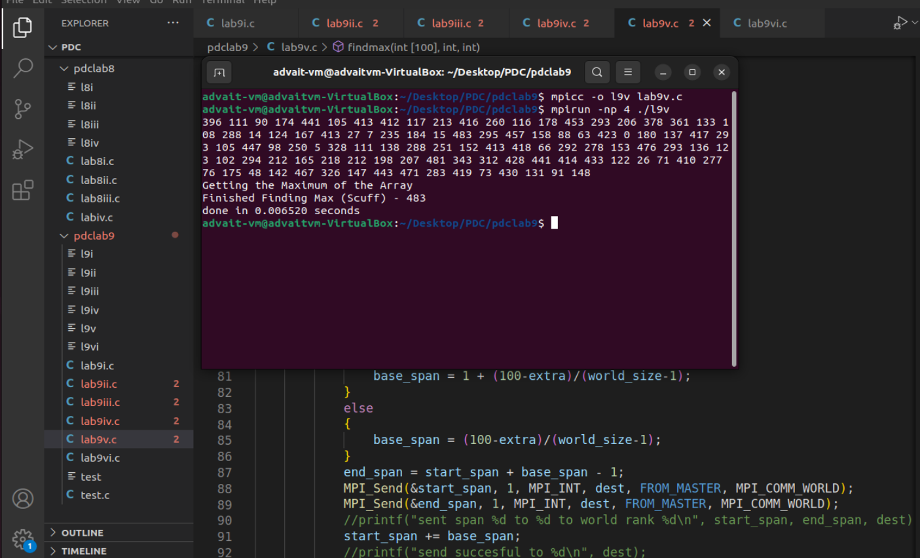

Code ->
#include<mpi.h>
#include<omp.h>
#include<stdio.h>
#include<stdlib.h>
#include<time.h>
#include<math.h>
#include<stdbool.h>
//#include<iostream>

//using namespace std;

#define MASTER 0
#define FROM_MASTER 1
#define FROM_WORKER 2

void printarr(int arr[100])
{
for(int i=0; i<100; i++)
printf("%d ", arr[i]);
printf("\n");
}

int findmax(int arr[100], int start_span, int end_span)
{
int loc_mx=0;
for(int span=start_span; span<end_span; span++)
{
//printf("currently checking %d\n", arr[span]);
loc_mx=arr[span]>loc_mx?arr[span]:loc_mx;
}
//printf("findmax ended successfully\n");
return loc_mx;
}

int main()
{
//MPI add number to matrix

MPI_Status status;

MPI_Init(NULL, NULL);

int world_size;
MPI_Comm_size(MPI_COMM_WORLD, &world_size);

int world_rank;
MPI_Comm_rank(MPI_COMM_WORLD, &world_rank);

//char processor_name[MPI_MAX_PROCESSOR_NAME];
//int name_len;
//MPI_Get_processor_name(processor_name, &name_len);
int full_arr[100];
int span_chart[100]={0};
int global_max_scuff=0;
//int global_max_reduce = 0;
int local_max=0;

srand(time(NULL));
for(int i=0; i<100; i++)
{
int x=rand()%500;
full_arr[i]=x;
}

int extra=100%(world_size-1);
int base_span;
int start_span=0;
int end_span;
//int dummy_sync = 0;
if(world_rank==0)
{
printarr(full_arr);
printf("Getting the Maximum of the Array\n");
double start = MPI_Wtime();

//sending
for(int dest=1; dest<=world_size-1; dest++)
{
if(dest<=extra)
{
base_span = 1 + (100-extra)/(world_size-1);
}
else
{
base_span = (100-extra)/(world_size-1);
}
end_span = start_span + base_span - 1;
MPI_Send(&start_span, 1, MPI_INT, dest, FROM_MASTER, MPI_COMM_WORLD);
MPI_Send(&end_span, 1, MPI_INT, dest, FROM_MASTER, MPI_COMM_WORLD);
//printf("sent span %d to %d to world rank %d\n", start_span, end_span, dest);
start_span += base_span;
//printf("send succesful to %d\n", dest);
}

//receiving
for(int source=1; source<=world_size-1; source++)
{
MPI_Recv(&local_max, 1, MPI_INT, source, FROM_WORKER, MPI_COMM_WORLD, &status);
//printf("received successfully from %d\n", source);
if(local_max>global_max_scuff)
global_max_scuff=local_max;
}

//MPI_Reduce(&local_max, &global_max_reduce, 1, MPI_INT, MPI_MAX, MASTER, MPI_COMM_WORLD);
printf("Finished Finding Max (Scuff) - %d\n", global_max_scuff);
//printf("Finished Finding Max (Reduce) - %d\n", global_max_reduce);
double finish = MPI_Wtime();
printf("done in %f seconds\n", finish-start);

}

if(world_rank!=0)
{
MPI_Recv(&span_chart[2*world_rank], 1, MPI_INT, MASTER, FROM_MASTER, MPI_COMM_WORLD, &status);
MPI_Recv(&span_chart[2*world_rank+1], 1, MPI_INT, MASTER, FROM_MASTER, MPI_COMM_WORLD, &status);
local_max = findmax(full_arr, span_chart[2*world_rank], span_chart[2*world_rank+1]);
//printf("local max from world %d is %d\n", world_rank, local_max);
MPI_Send(&local_max, 1, MPI_INT, MASTER, FROM_WORKER, MPI_COMM_WORLD);
//printf("sucessfull send from world %d\n", world_rank);

}

MPI_Finalize();
return 0;
}

Q5) Four Queen's Problem
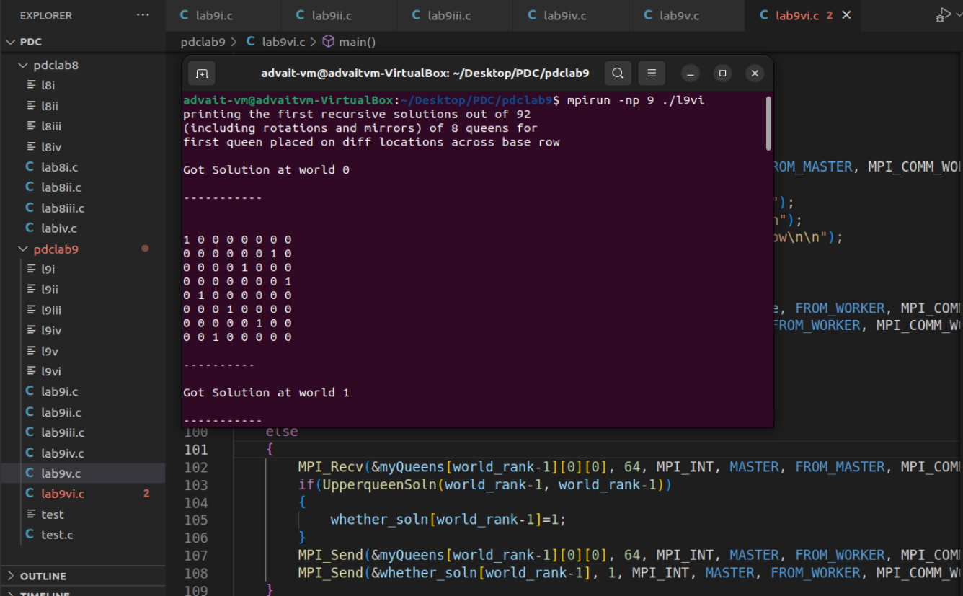

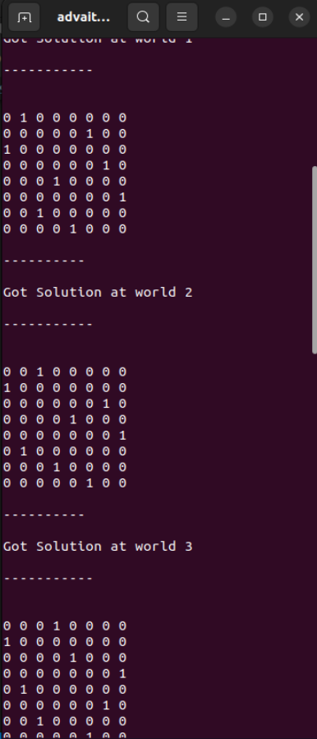
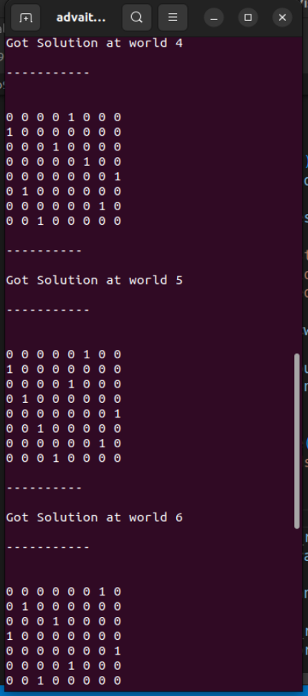

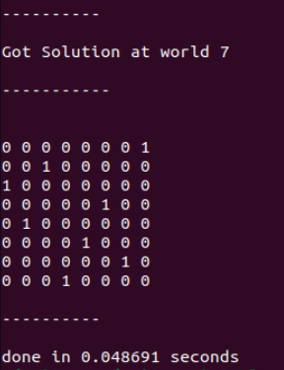

Code -> Long

//recursion pseudo
//place first queen at [rank][0]
//for X in 0:8
//for Y in 0:8
//if X,Y == 0
//place queen
//invalidate(x, y) - add 1 to all squares
//recurse
//remove queen
//validate(x, y) - sub 1 from all squares
//if placed==8
//print matrix
/*************************************
* after more consideration, above method is kinda unfeasible, because of
* 0s (blank possible spaces for queen) appearing at the end and
* messing with stuff later
* Going back to normal n-Queens
* **********************************/

/*****************
* Normal n-Queens algo -
* isSafe(x, y, board) -> check diagonals and row/cols of (x, y) of board
* Recursive bool nQueen(board, current col)
* -if(col>=boardLength) -> return True (board is full with N Queens)
* -for(row space in the given column)
* -if isSafe(row space, col, board)
* -{
* - board(row space, col) = 1
* - if(recursive nQueens(board, next col))
* - return true
* - board(row space, col) = 0 -> backtrack
* -}
*
*
* main()
* {
* if(recursive nQeeun(board, world_rank))
* print(solution)
* else
* print("no sol found")
* }
* ***************/
#include<mpi.h>
#include<stdlib.h>
#include<stdio.h>
#include<stdbool.h>

#define MASTER 0
#define FROM_MASTER 1
#define FROM_WORKER 2

int myQueens[8][8][8] = {0};
//ideally only need one 8x8 matrix, not 8 sets. but im too lazy to recode
int whether_soln[8]={0};
int synchronizer=0;

bool UpperqueenSoln(int boardNum, int col);
bool queenSoln(int boardNum, int col);
bool checkCols(int boardNum, int row, int col);
bool checkSafe(int boardNum, int row, int col);
void printsols();
void printarray(int boardNum);

int main()
{

MPI_Status status;

MPI_Init(NULL, NULL);

int world_size;
MPI_Comm_size(MPI_COMM_WORLD, &world_size);

int world_rank;
MPI_Comm_rank(MPI_COMM_WORLD, &world_rank);

if(world_rank==MASTER)
{
double start = MPI_Wtime();
for(int dest=1; dest<world_size; dest++)
{
MPI_Send(&myQueens[dest-1][0][0], 64, MPI_INT, dest, FROM_MASTER, MPI_COMM_WORLD);//synchronize and signal start of the program
}
printf("printing the first recursive solutions out of 92\n");
printf("(including rotations and mirrors) of 8 queens for\n");
printf("first queen placed on diff locations across base row\n\n");

for(int source=1; source<world_size; source++)
{
MPI_Recv(&myQueens[source-1][0][0], 64, MPI_INT, source, FROM_WORKER, MPI_COMM_WORLD, &status);
MPI_Recv(&whether_soln[source-1], 1, MPI_INT, source, FROM_WORKER, MPI_COMM_WORLD, &status);//synchronize receive and whether a solution has been found or not
}
printsols();
double finish = MPI_Wtime();
printf("done in %f seconds\n", finish-start);
}
else
{
MPI_Recv(&myQueens[world_rank-1][0][0], 64, MPI_INT, MASTER, FROM_MASTER, MPI_COMM_WORLD, &status);//sync start
if(UpperqueenSoln(world_rank-1, world_rank-1))
{
whether_soln[world_rank-1]=1;
}
MPI_Send(&myQueens[world_rank-1][0][0], 64, MPI_INT, MASTER, FROM_WORKER, MPI_COMM_WORLD);
MPI_Send(&whether_soln[world_rank-1], 1, MPI_INT, MASTER, FROM_WORKER, MPI_COMM_WORLD);//sync
}

MPI_Finalize();

return 0;
}

bool UpperqueenSoln(int boardNum, int col)
{
myQueens[boardNum][0][col]=1;
return(queenSoln(boardNum, 0));
}

bool queenSoln(int boardNum, int col)
{
if(col >= 8)
return true;
for(int i=0; i<8; i++)
{
if(checkSafe(boardNum, i, col))
{
if(checkCols(boardNum, i, col))
{
if(queenSoln(boardNum, col+1))
return true;
}
else{
myQueens[boardNum][i][col] = 1;
if(queenSoln(boardNum, col+1))
return true;
/*if(boardNum==7)
printarray(boardNum);
*/myQueens[boardNum][i][col] = 0;
}
}
}
return false;
}

bool checkCols(int boardNum, int row, int col)
{
//across the col set by og queen call
for(int j=0; j<8; j++)
if(myQueens[boardNum][j][col])
return true;

return false;
}

bool checkSafe(int boardNum, int row, int col)
{
//edge case check
if(boardNum==7 && col==7)
return true;

//across the row
for(int i=0; i<8; i++)
if(myQueens[boardNum][row][i])
return false;

//upper left diag
for(int i=row, j=col; i>=0 && j>=0; i--, j--)
if(myQueens[boardNum][i][j])
return false;

//lower right diag
for(int i=row, j=col; i<=7 && j<=7; i++, j++)
if(myQueens[boardNum][i][j])
return false;

//lower left diag
for(int i=row, j=col; i < 8 && j>=0; i++, j--)
if(myQueens[boardNum][i][j])
return false;

//upper right diag
for(int i=row, j=col; i>=0 && j<8; i--, j++)
if(myQueens[boardNum][i][j])
return false;

return true;
}

void printsols()
{
for(int i=0; i<8; i++)
{
if(whether_soln[i])
{
printf("Got Solution at world %d\n\n-----------\n", i);
printarray(i);
printf("\n----------\n\n");
}
else
printf("no solution from world %d\n\n----------\n\n", i);
}
}

void printarray(int boardNum)
{
printf("\n");
for(int i=0; i<8; i++)
{
printf("\n");
for(int j=0; j<8; j++)
{
printf("%d ", myQueens[boardNum][i][j]);
}
}
printf("\n");
}

